Alphonz George

T11-03

Assignment 4

Aim: To enhance the existing web page using Bootstrap, we will incorporate Bootstrap's classes for the grid system, forms, buttons, navbar, breadcrumb, and jumbotron. Below is the updated HTML code that integrates Bootstrap components, making it look more polished and responsive without needing custom CSS.

Updated HTML with Bootstrap Integration

1. **Grid System**: Utilizes Bootstrap’s grid layout to structure the content.
2. **Forms**: Enhanced with Bootstrap’s form controls for better styling.
3. **Buttons**: Styled using Bootstrap button classes.
4. **Navbar**: A responsive Bootstrap navbar is added at the top.
5. **Breadcrumb**: Provides a navigation trail for the user.
6. **Jumbotron**: Added for a prominent, engaging section at the top of the page.

Code:

<!DOCTYPE html>

<html lang="en">

<head>

<meta charset="UTF-8">

<meta name="viewport" content="width=device-width, initial-scale=1.0">

<title>Bookstore</title>

<link rel="stylesheet" href="style.css">

</head>

<body>

<!-- Navbar -->

<nav class="navbar">

<ul>

<li><a href="#home">Home</a></li>

<li><a href="#bestsellers">Bestsellers</a></li>

<li><a href="#newarrivals">New Arrivals</a></li>

<li><a href="#categories">Categories</a></li>

<li><a href="#contact">Contact</a></li>

</ul>

</nav>

<!-- Breadcrumb -->

<ul class="breadcrumb">

<li><a href="#home">Home</a></li>

<li>&gt;</li>

<li>Bestsellers</li>

</ul>

<!-- Jumbotron -->

<div class="jumbotron">

<h1>Welcome to Our Bookstore</h1>

<p>Your gateway to a world of knowledge and imagination</p>

<a href="#bestsellers" class="btn">Explore Bestsellers</a>

</div>

<!-- Content Section -->

<div class="container">

<div class="row">

<!-- Bestsellers Section -->

<div class="col-12 col-md-6">

<h2 id="bestsellers">Bestsellers</h2>

<table>

<tr>

<th>Book Cover</th>

<th>Title</th>

<th>Author</th>

<th>Price</th>

</tr>

<tr>

<td><img src="bestseller1.jpg" alt="Book Cover 1"

width="100"></td>

width="100"></td>

<td>The Great Gatsby</td>

<td>F. Scott Fitzgerald</td>

<td>$10.99</td>

</tr>

<tr>

<td><img src="bestseller2.jpg" alt="Book Cover 2"

<td>1984</td>

<td>George Orwell</td>

<td>$8.99</td>

</tr>

</table>

</div>

<!-- New Arrivals Section -->

<div class="col-12 col-md-6">

<h2 id="newarrivals">New Arrivals</h2>

width="100">

width="100">

<ol>

<li>

<img src="newarrival1.jpg" alt="New Arrival 1"

<p><strong>Title:</strong> The Silent Patient</p>

<p><strong>Author:</strong> Alex Michaelides</p>

<p><strong>Price:</strong> $14.99</p>

</li>

<li>

<img src="newarrival2.jpg" alt="New Arrival 2"

<p><strong>Title:</strong> Where the Crawdads Sing</p>

<p><strong>Author:</strong> Delia Owens</p>

<p><strong>Price:</strong> $12.99</p>

</li>

</ol>

</div>

</div>

</div>

<!-- Contact Us Form -->

<div class="container">

<h2 id="contact" class="text-center">Contact Us</h2>

<form action="submit_form.php" method="post" class="form-group">

<p>

<label for="name">Name:</label>

<input type="text" id="name" name="name">

</p>

<p>

<label for="email">Email:</label>

<input type="email" id="email" name="email">

</p>

<p>

<label for="message">Message:</label>

<textarea id="message" name="message"></textarea>

</p>

<p>

<input type="submit" value="Submit">

</p>

</form>

</div>

</body>

</html>

Output:

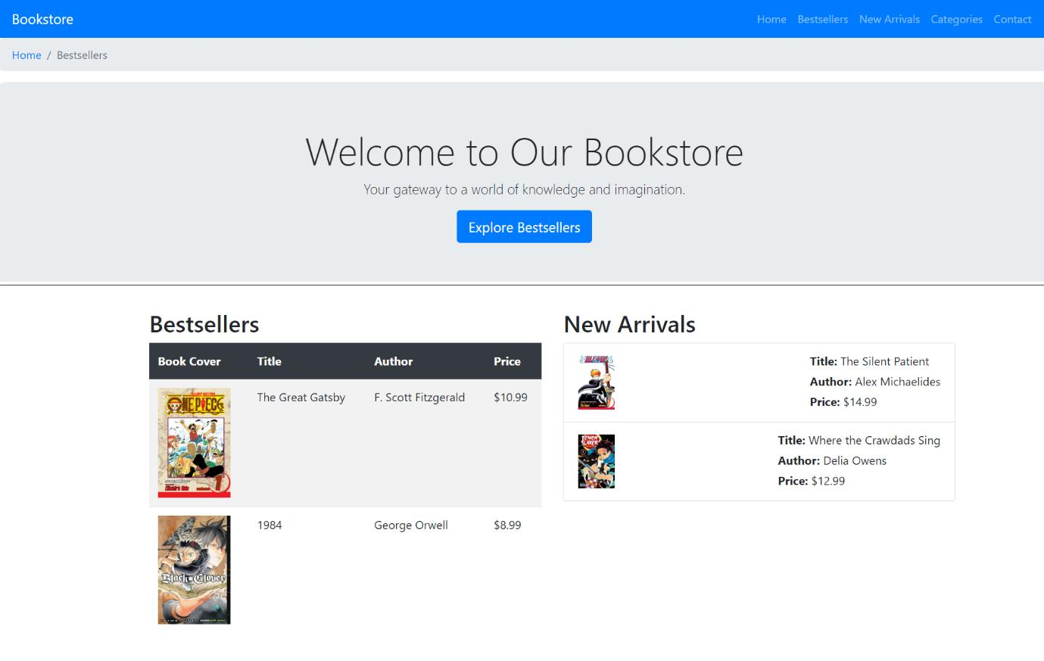

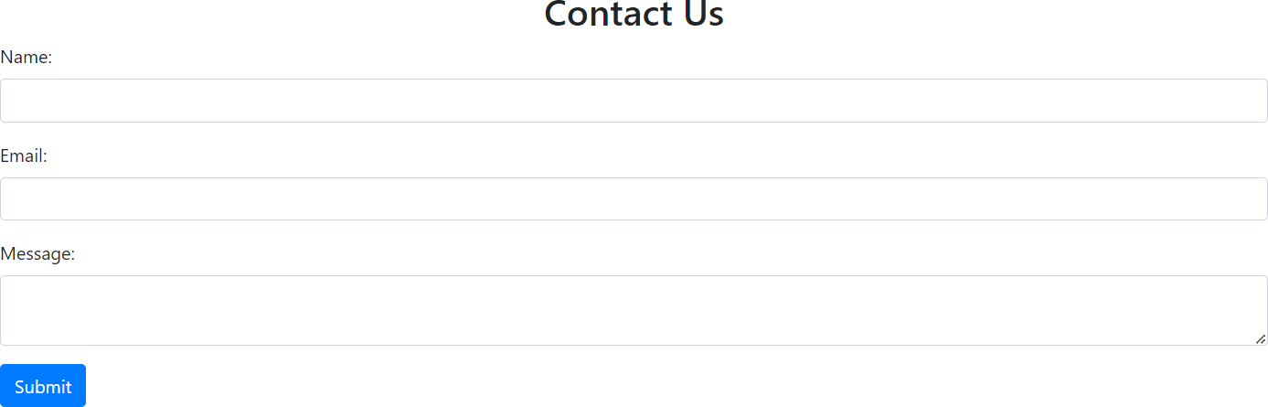

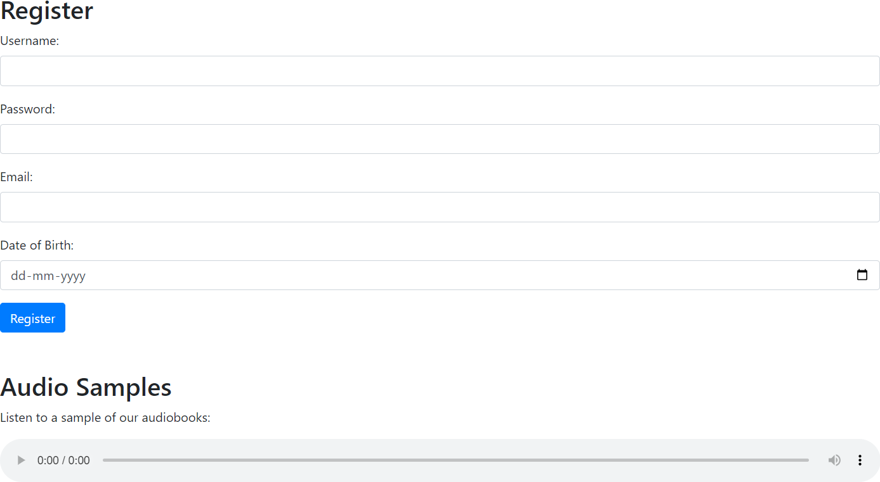

Conclusion:

This approach leverages Bootstrap’s powerful classes, making your webpage responsive and visually appealing without needing extensive custom CSS.